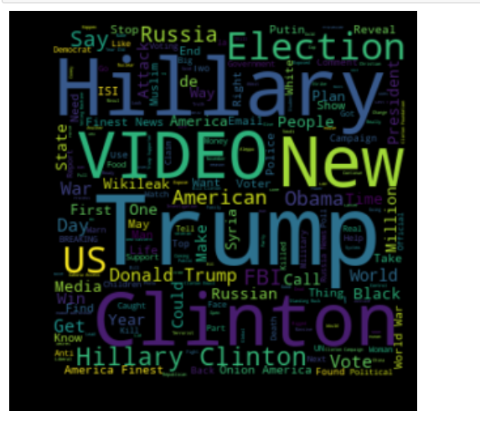

Word cloud for real news

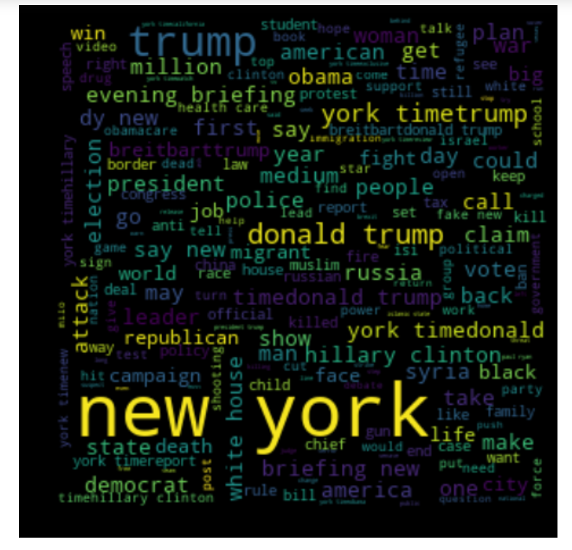

Word Cloud for fake news

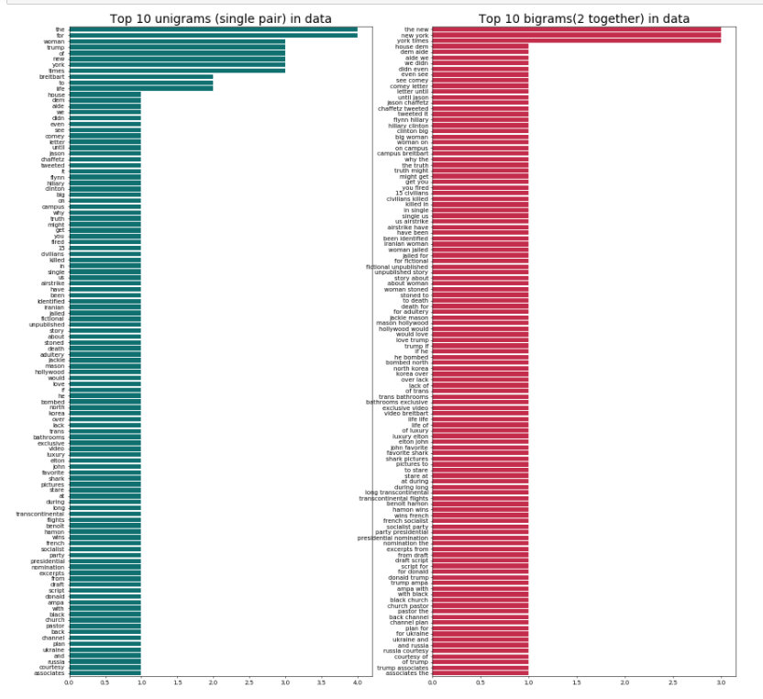

Above fig is showing N gram analysis , what are single word and what are pair of word in our data

Classification Report Result :

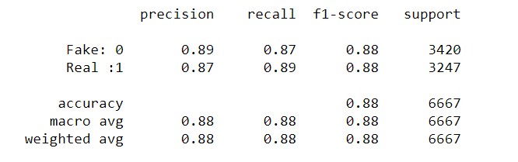

Confusion matrix

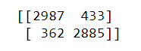

This value are represneted in graph form below actual o/p vs predicted o/p

